**­PHPE-BOOKS e-Project**



***Submitted To***

[eprojects@aptech.ac.in](mailto:eprojects@aptech.ac.in)

***Project Instructor***

Hafiz Owais Imam

***Curriculum Code***

7062

***group members:***

*Muhammad Fuzail Yasin Khan*

*Student*

*Muhammad Farooq Sheikh*

*Student*



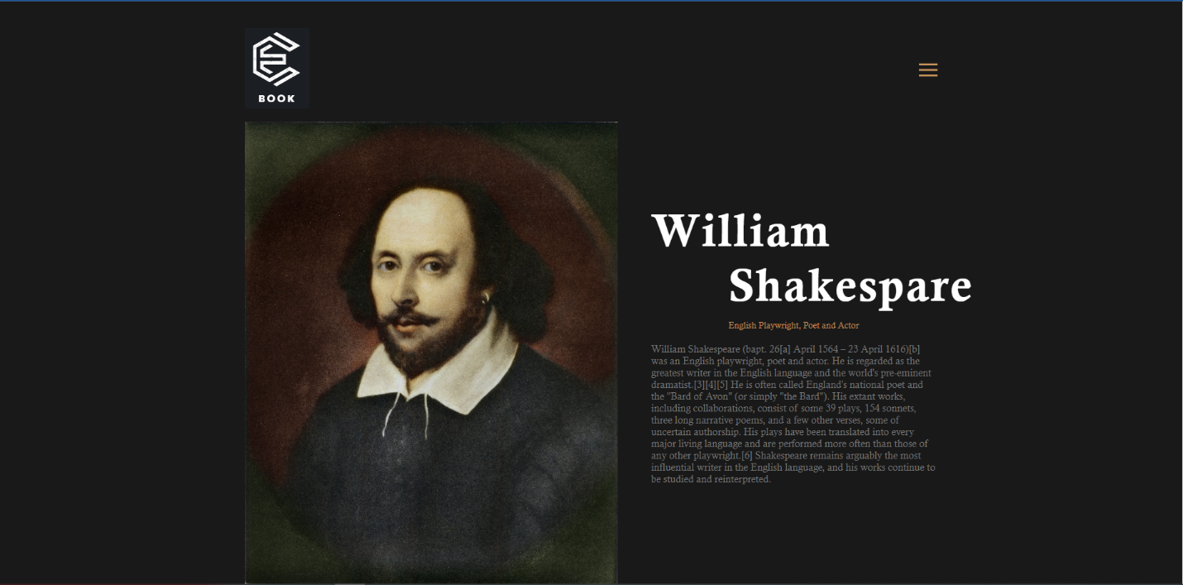

**Header**

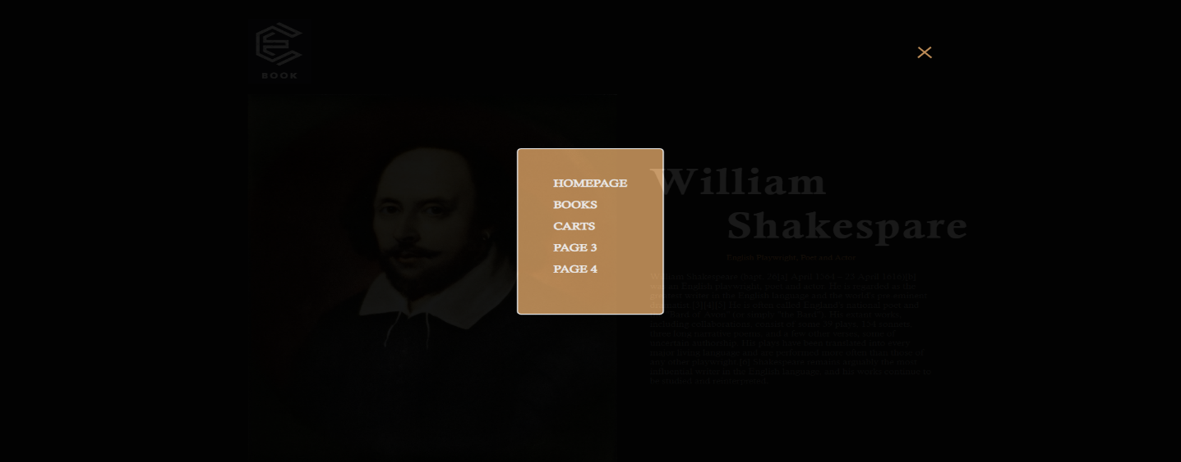

**Navigation Bar**

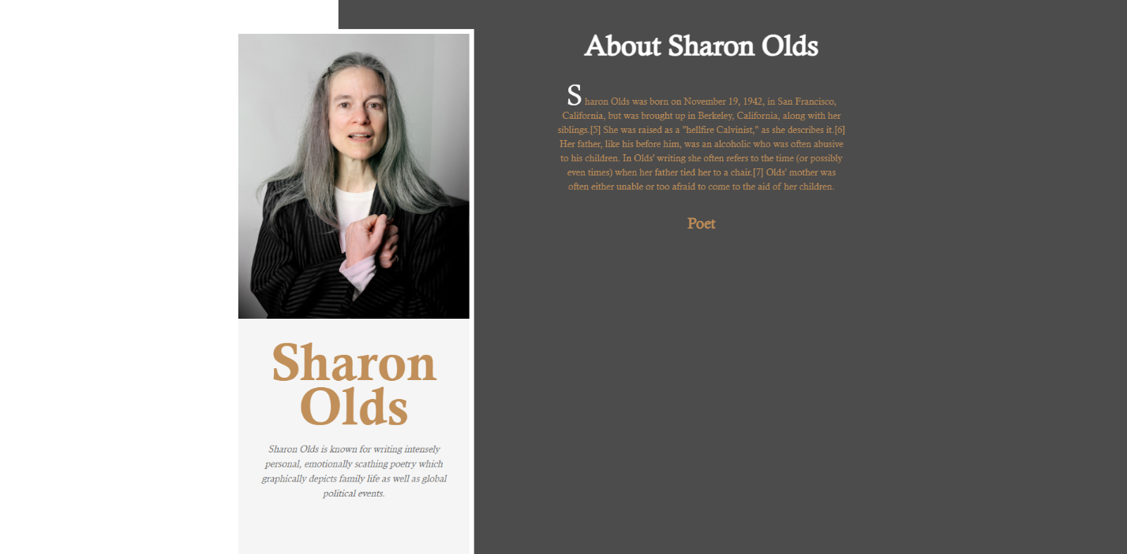

**About Us**

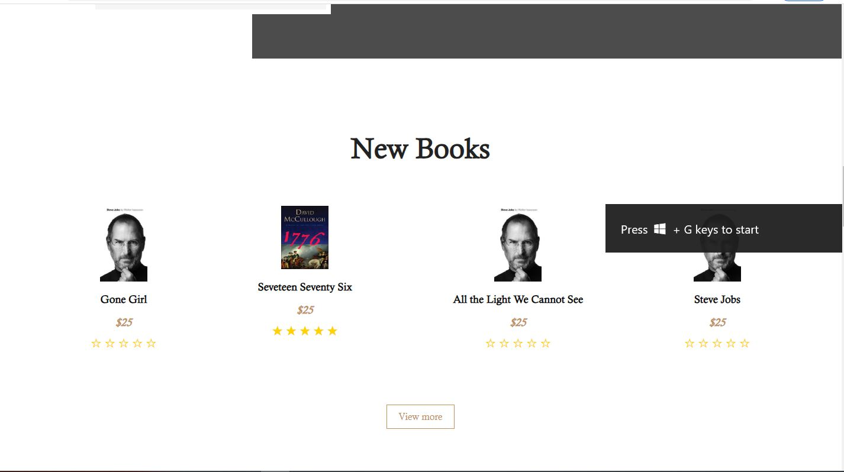

**Books carts**

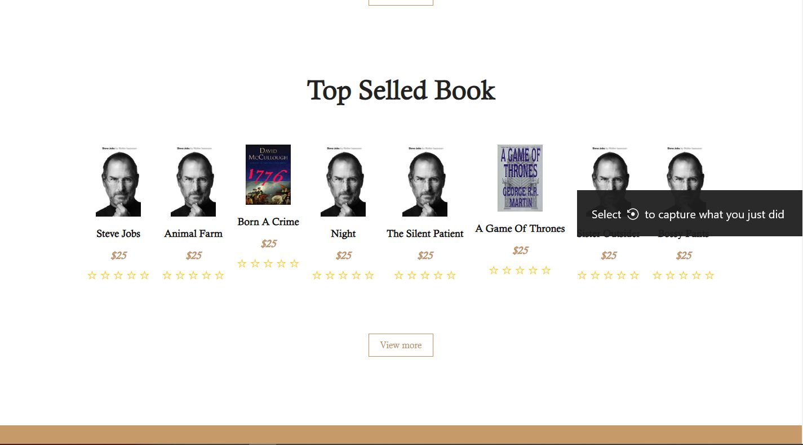

**Top Selled Books**

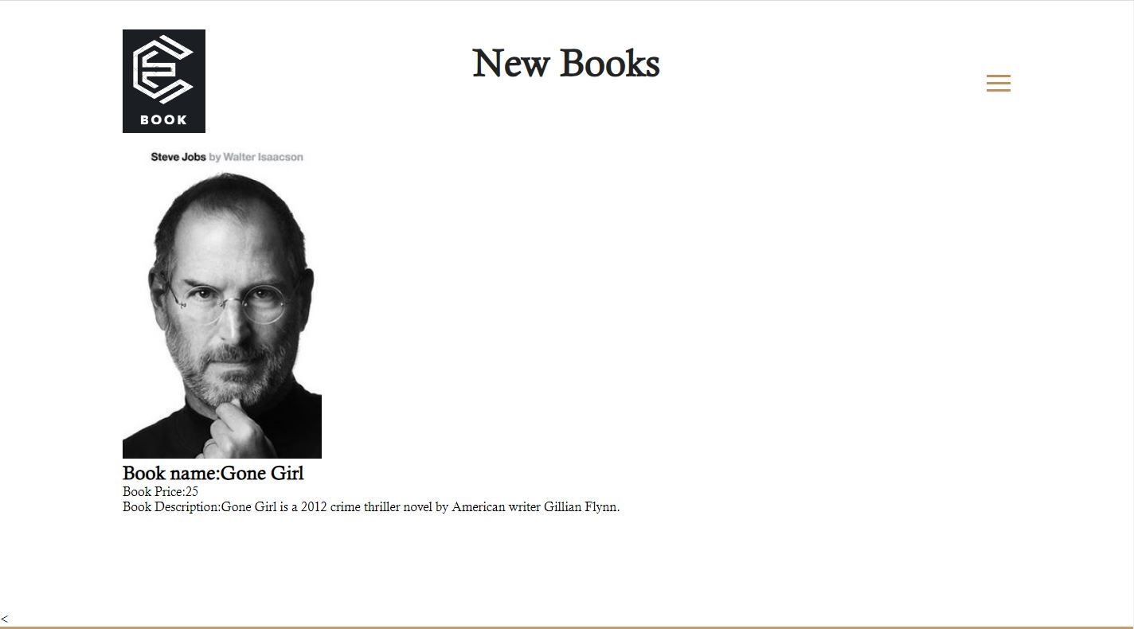

**Book Description**

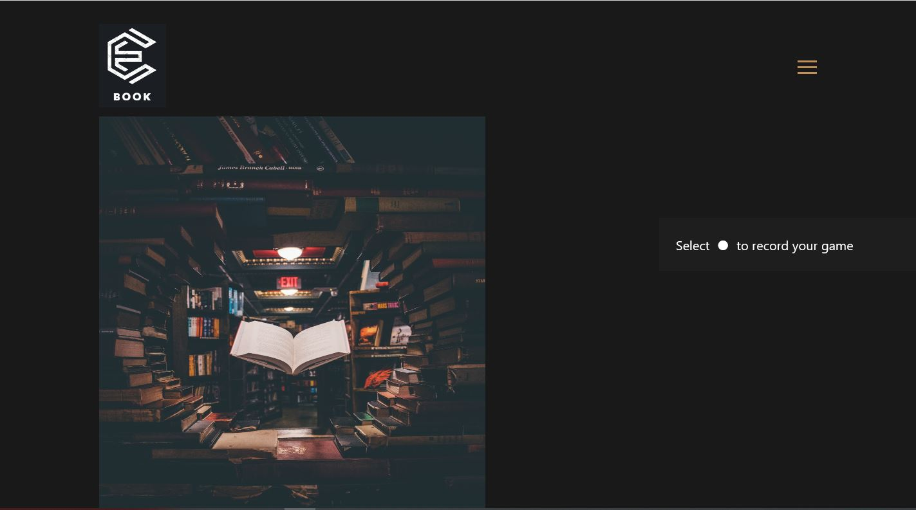

**Book Page**

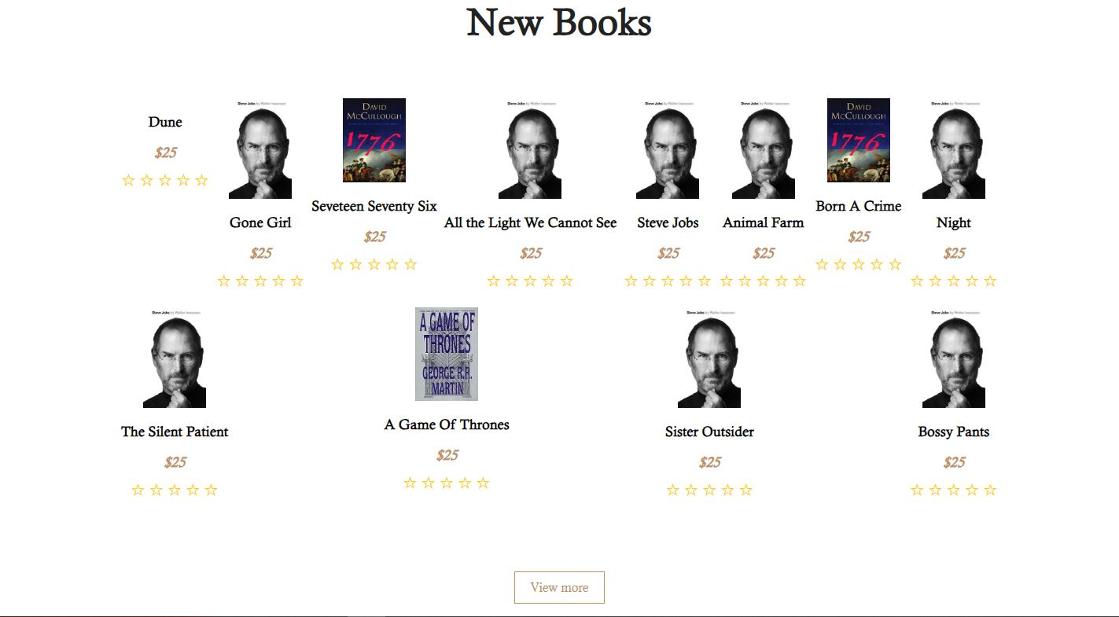

**New Books**



**Awards**



**Comments Section**

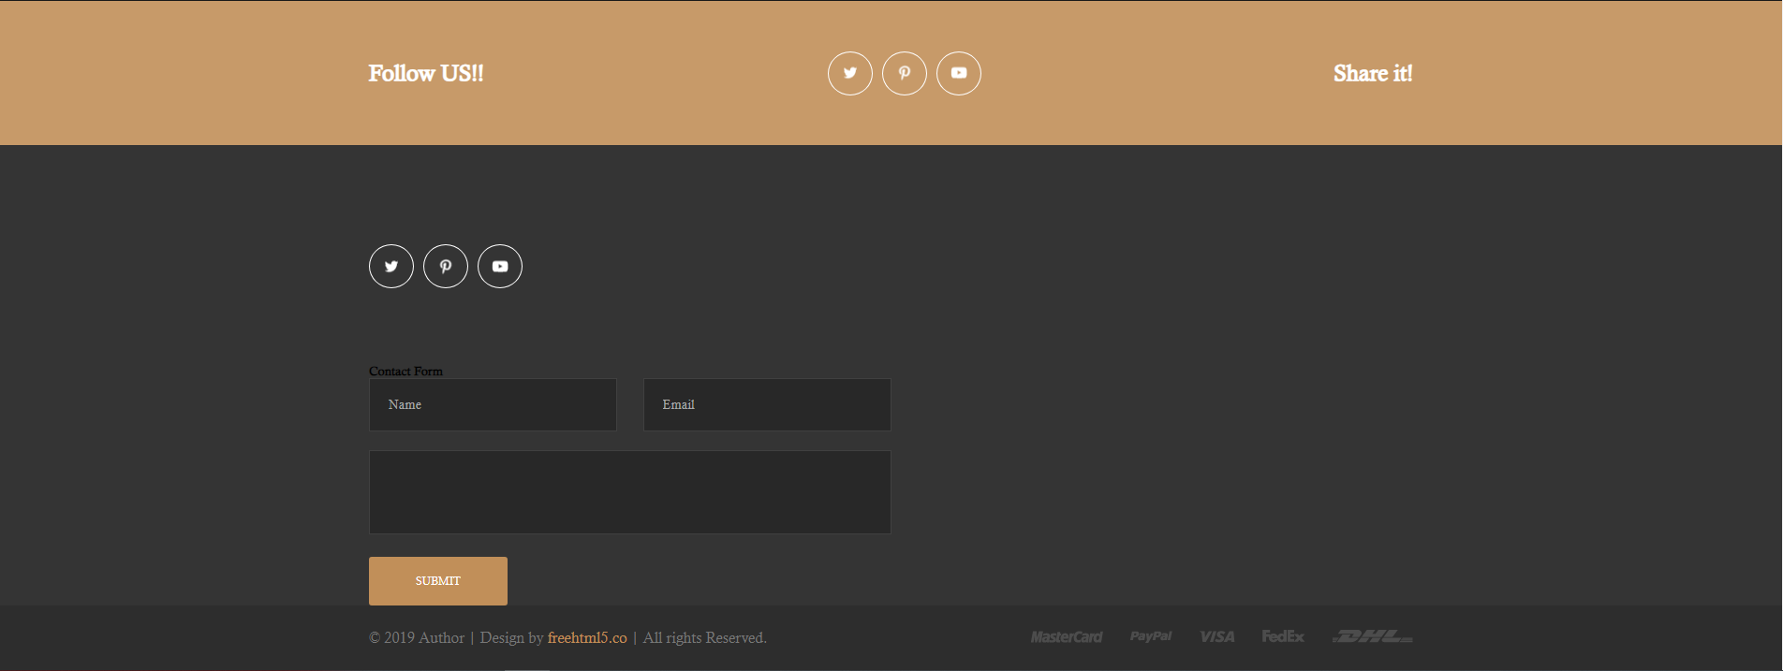

**Footer**